PARAGRAPH COHERENCE and UNITY
English 8
Mrs. Woodliffe

Coherence
Coherence literally means “to stick together”. Coherence in paragraph writing means all the sentences are arranged in a clear, logical order. A paragraph is coherent when all of the ideas support the topic sentence and allow the reader to easily understand the ideas you want to express.

Paragraphs are made coherent by
1. The arrangement of the points
2. The logical connections between the points

1. Arrangement of Ideas – when you build a house, you cannot put the roof on before the walls. Similarly, in a paragraph, you cannot skip around from one idea to the next without some sort of arrangement of the points; otherwise, the reader may become confused.

There are several ways to arrange ideas in a paragraph:

A. Chronological order – points or events are arranged in the same order they occur in time (earliest to latest). This works well in narrative paragraphs, as well as process and description.

B. Spatial order – points or ideas are arranged in some kind of order of space, such as top to bottom, near to far, or left to right. This works well in descriptive paragraphs.

C. Sequential order – points or events are arranged in order of importance (least to most or most to least), order of general to specific, or least familiar to most familiar

2. Logical Connection between Ideas – when you connect the cars of a train, there is a specific order that works best for pulling; however, if the cars are not connected to each other, the train will not move. Similarly, in a paragraph, words are used to provide the connection between the ideas or point.

There are several ways to connect ideas in a paragraph:

A. Transitional words – these are usually divided into categories according to purpose, such as to show location, time, emphasis, contrast, or summary (see chart on next page for numerous examples).

B. Linking sentences – use repeating key words, use pronouns, or use other transitional coordinators or subordinators (see chart on next page for examples).

Unity
Unity means that the paragraph is about only one main idea or topic. All the sentences in the paragraph (topic, supporting/detail sentences and conclusion) are telling the reader about the same idea. If there is a sentence that is not directly related to the main topic, the paragraph is considered to “lack unity” and any sentences that are off topic should be removed.

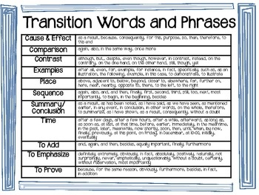

There are a variety of ways to make your writing more cohesive, here are a few ideas:
- Repeating key words: use the same word or its synonym again.
- Using pronouns (it, they, this, that, these, those, etc) link back to nouns.
- Using transition signals: coordinators, subordinators and sentence connectors.
Make sure that each sentence starts with a reference back to the previous sentence.
Model paragraph
There are many people who claim that global warming is the most significant threat facing us today. They argue that it is a danger not just to the current generation, but also to the generations to come. Indeed, it is this threat to our future that is of most concern. One effect of global warming is there will not be enough food to feed the world in the near future.

SENTENCE CONNECTORS
Using sentence connectors is one of the ways to make a paragraph coherent.
Sentence connectors are words or phrases that indicate the relationship among sentences.
Sentence connectors often stand at the beginning of a sentence and followed by a comma.
Function | Sentence connectors
To introduce the first idea | First of all, | Firstly, | First and foremost, | To start with,
To introduce an additional idea | Secondly, | Moreover, | In addition, | Furthermore,
To introduce an opposite idea | However, | In contrast, | On the other hand, | Nevertheless,
To introduce a similar idea | Likewise, | Similarly, | In the same way,
To introduce an alternative | Otherwise, | Instead, | Alternatively,
To introduce an example | For instance, | For example, | As an illustration, | To illustrate,
To introduce a result | Therefore, | Thus, | Consequently, | As a result,
To introduce the last idea | Lastly, | Finally, | Last but not least,
To introduce a conclusion | In brief, | Overall, | To summarize | In conclusion,

Exercise 1 Fill in the blanks with suitable transition words

Each of the U.S. manned space exploration project has specific major goals. (1)______________________, the Mercury project was designed to test whether or not human beings could survive and function in outer space. (2) ____________________, the Mercury project tested rockets with the new Mercury space capsule, which could hold one person. (3) ____________________, the Gemini project was carried out to find out whether two people could work in the weightless environment of space. (4)_________________, Gemini astronauts were sent out to take “spacewalks.” (5)_______________________, they floated outside their spacecraft in a spacesuit, connected by a tether.
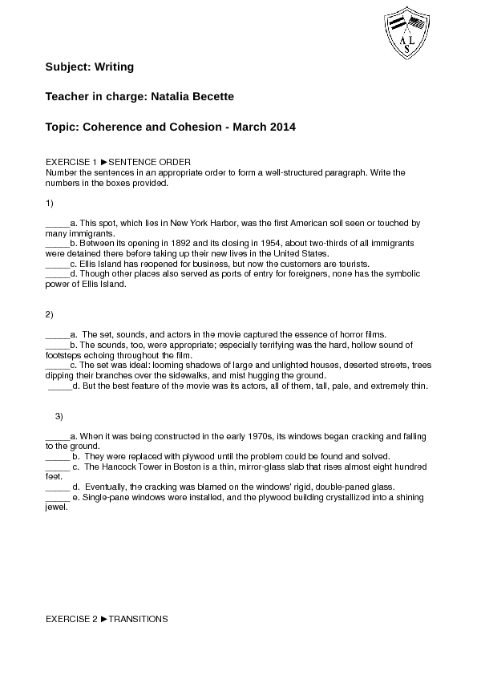

Coherence Paragraph Checklist

English 8
Mrs. Woodliffe Name __________________

Part A. Paragraph Structure

Please check the following items were completed:

- Word processed (or at least blue or black ink, or dark pencil)
- Neat and legible
- First line is indented

If any of these items are not checked, the paragraph cannot be marked and must be resubmitted.

If these items are all checked, move to the second checklist below:

- Topic sentence “On the bus next to me sat the strangest looking person I have ever seen.” (or something like it)
- 6-8 details sentences
- The sentences linked with transition words
- The sentences are arranged in a logical order
- Concluding sentence that is not a detail, and summarizes or restates the topic sentence

Part B. Paragraph Content

You did not have to create the content, you just had to copy it, so this should be correct!

Part C. Paragraph Mechanics

- All words are spelled correctly
- Capitals are used correctly
- There are periods, commas, and end punctuation in the paragraph.

Additional Comments?

